**--------------------🡪 Scala functions -----------------------🡪**

Map Functions --> It takes function as argument and apply to each and every elements passed to it as a range.

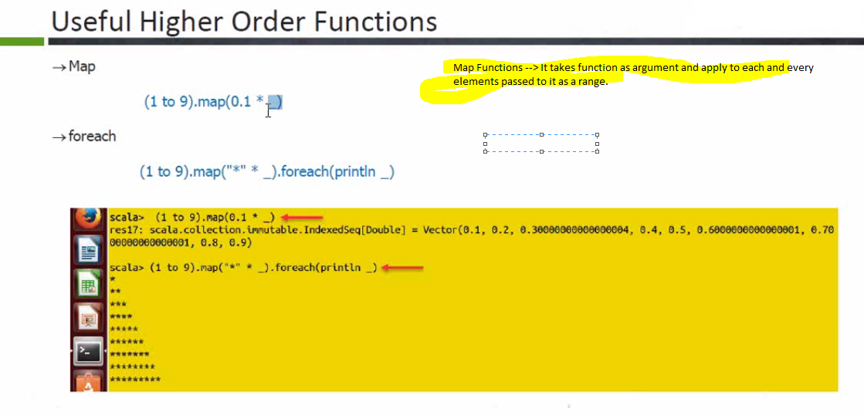

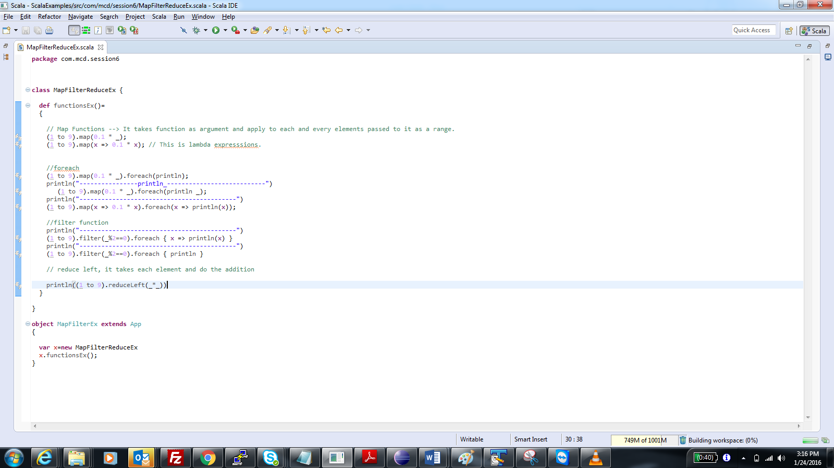

**-----------------------------------------🡪 Anonymous functions in scala --------------------------------🡪**

* println is one example of anonymous functions.
* if a function takes argument and if we want to write the implementation of that function, then we have to wirte it everytime, to overcome that we can use anonymous functions.
* functions which don’t have name are called anonymous functions.

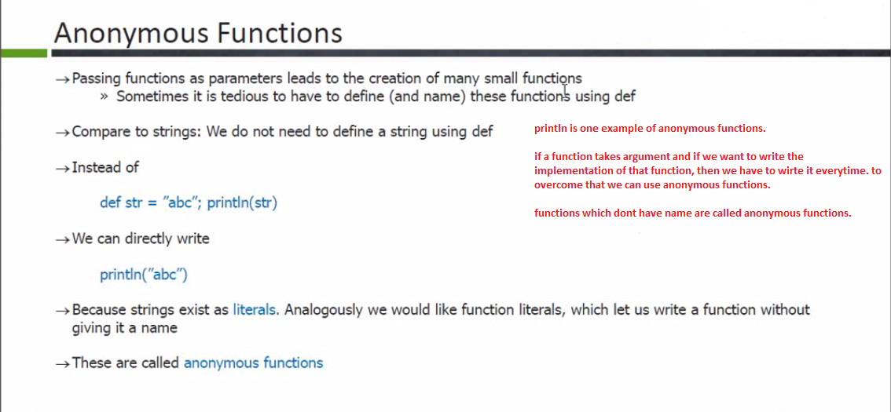

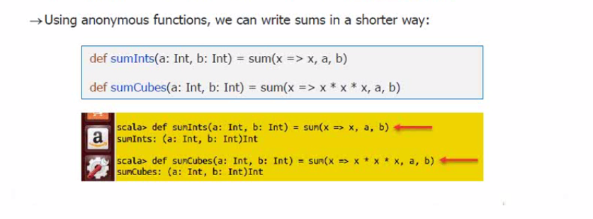

****************** _ in Scala *****************

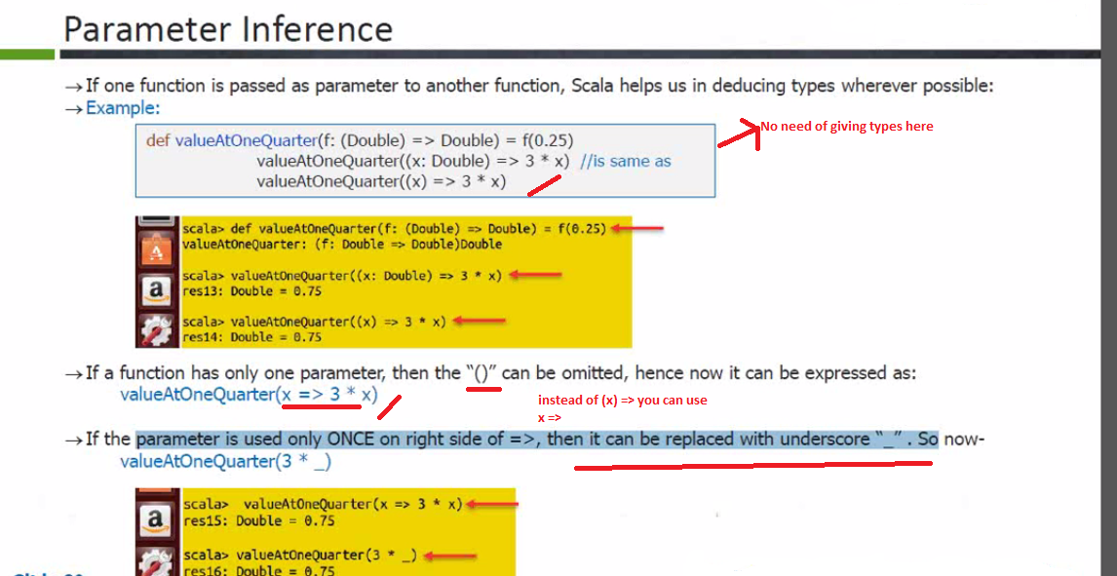

**-------------------------🡪Closuers In Scala ----------------------🡪**

A **closure** is a function, whose return value depends on the value of one or more variables declared outside this function. Consider the following piece of code with anonymous function:

val multiplier = (i:Int) => i * 10

Here the only variable used in the function body, i * 0, is i, which is defined as a parameter to the function. Now let us take another piece of code:

val multiplier = (i:Int) => i * factor

There are two free variables in multiplier: **i** and **factor**. One of them, i, is a formal parameter to the function. Hence, it is bound to a new value each time multiplier is called. However, **factor** is not a formal parameter, then what is this? Let us add one more line of code:

var factor = 3

val multiplier = (i:Int) => i * factor

Now, **factor** has a reference to a variable outside the function but in the enclosing scope. Let us try the following example:

object Test {

def main(args: Array[String]) {

println( "muliplier(1) value = " + multiplier(1) )

println( "muliplier(2) value = " + multiplier(2) )

}

var factor = 3

val multiplier = (i:Int) => i * factor

}

When the above code is compiled and executed, it produces the following result:

C:/>scalac Test.scala

C:/>scala Test

muliplier(1) value = 3

muliplier(2) value = 6

C:/>

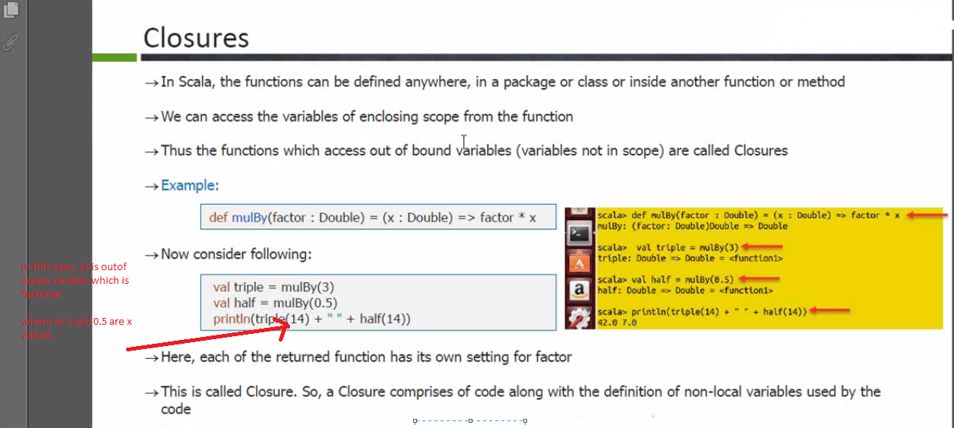

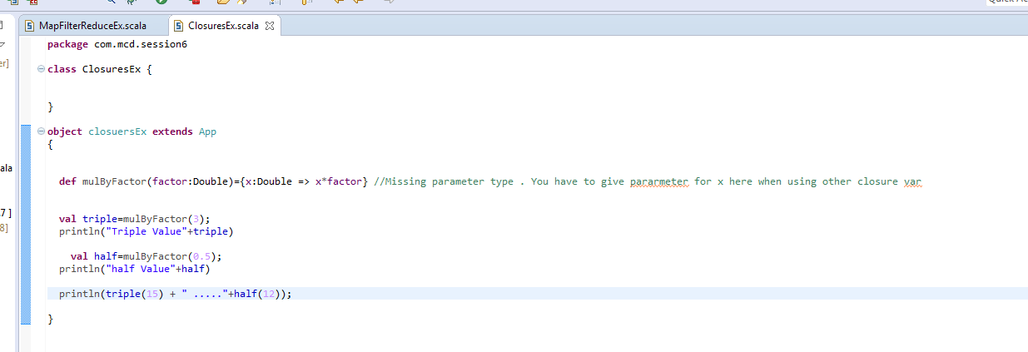

**File Processing in Scala ------------🡪**

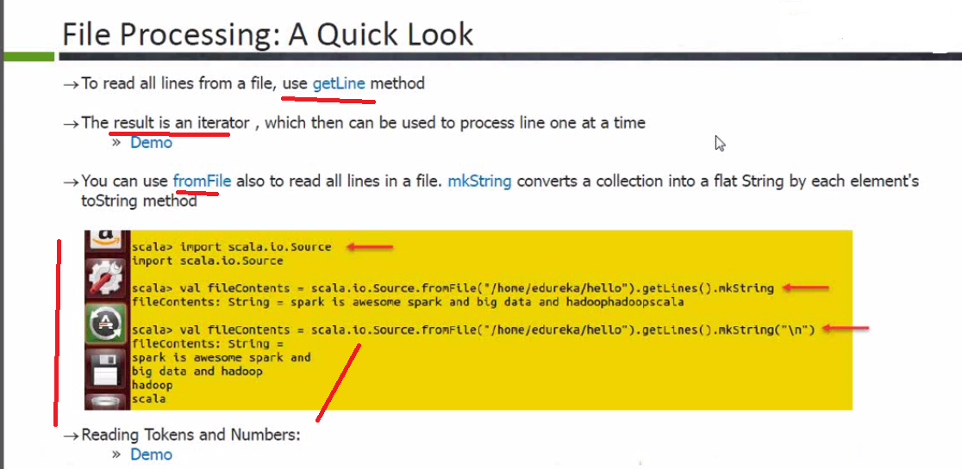

**Spark:**

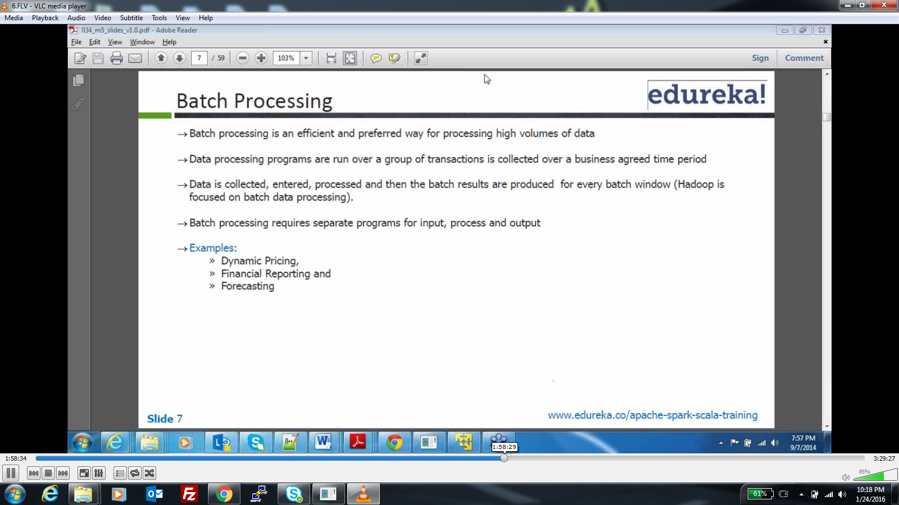

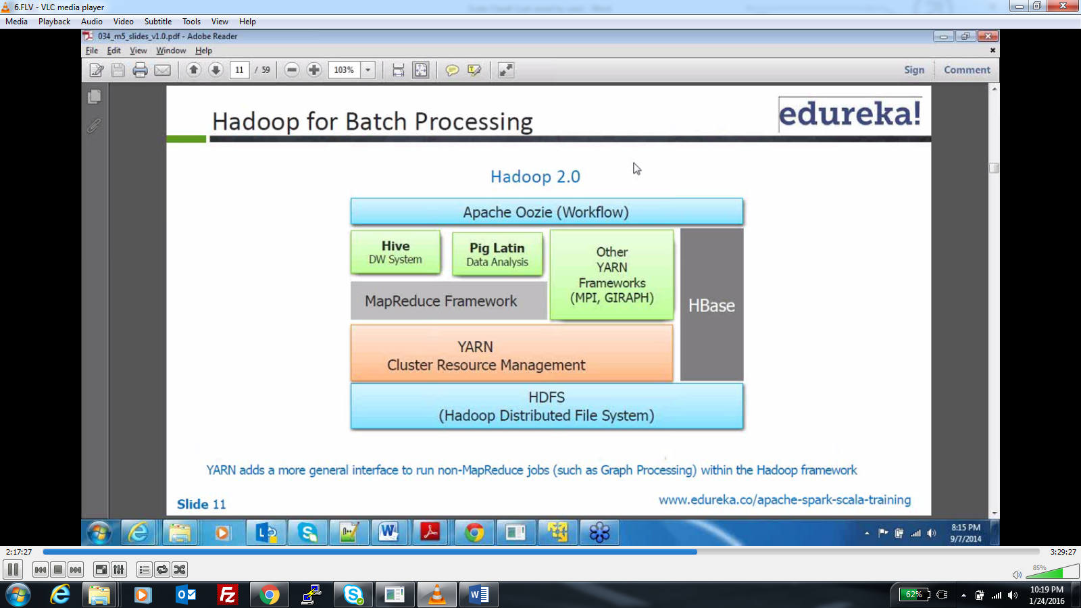

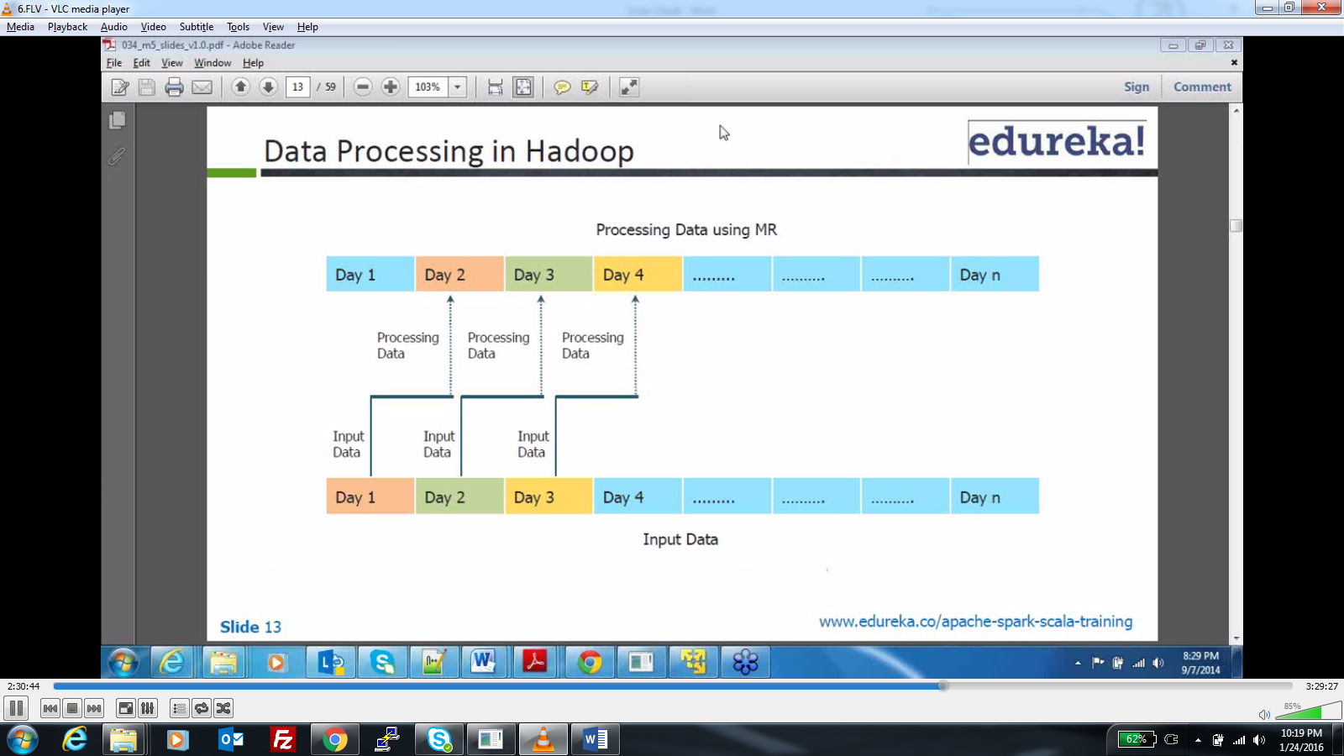

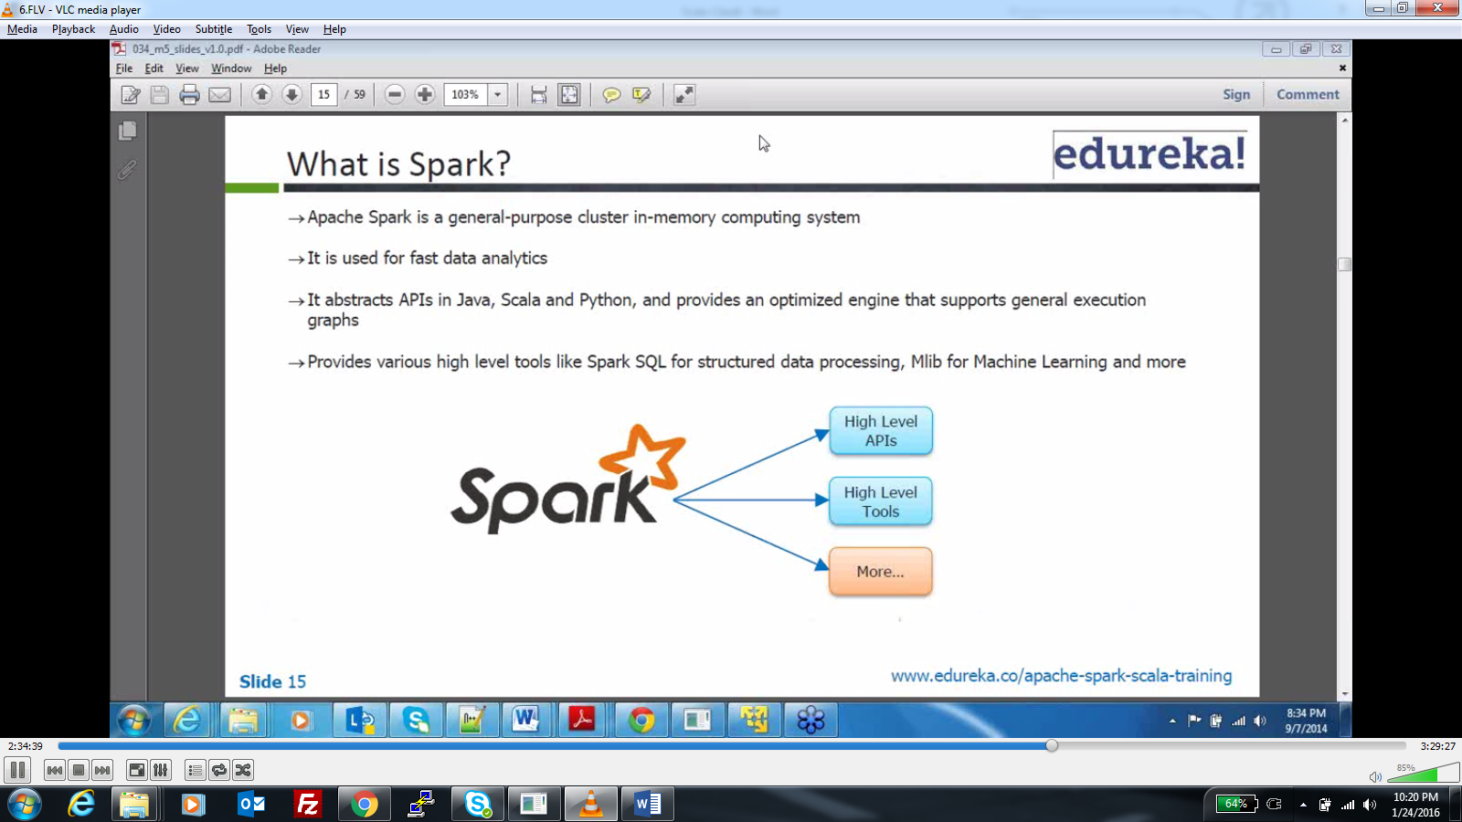

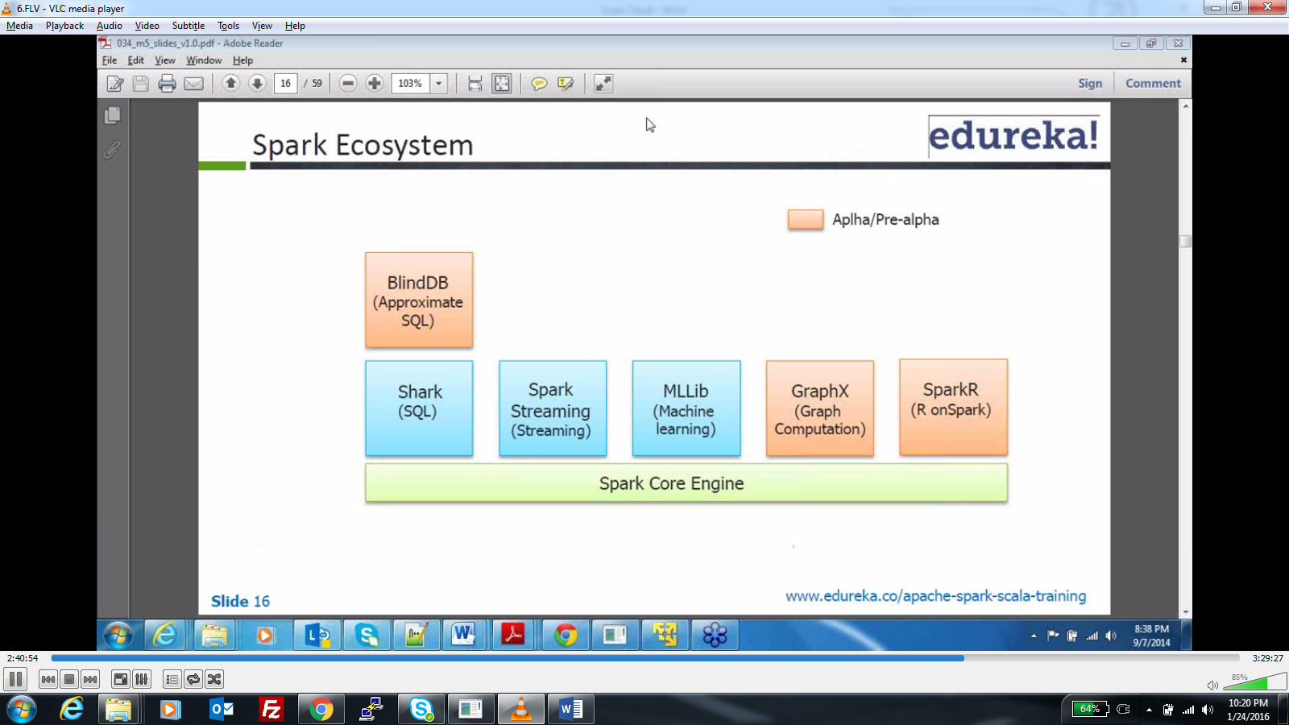

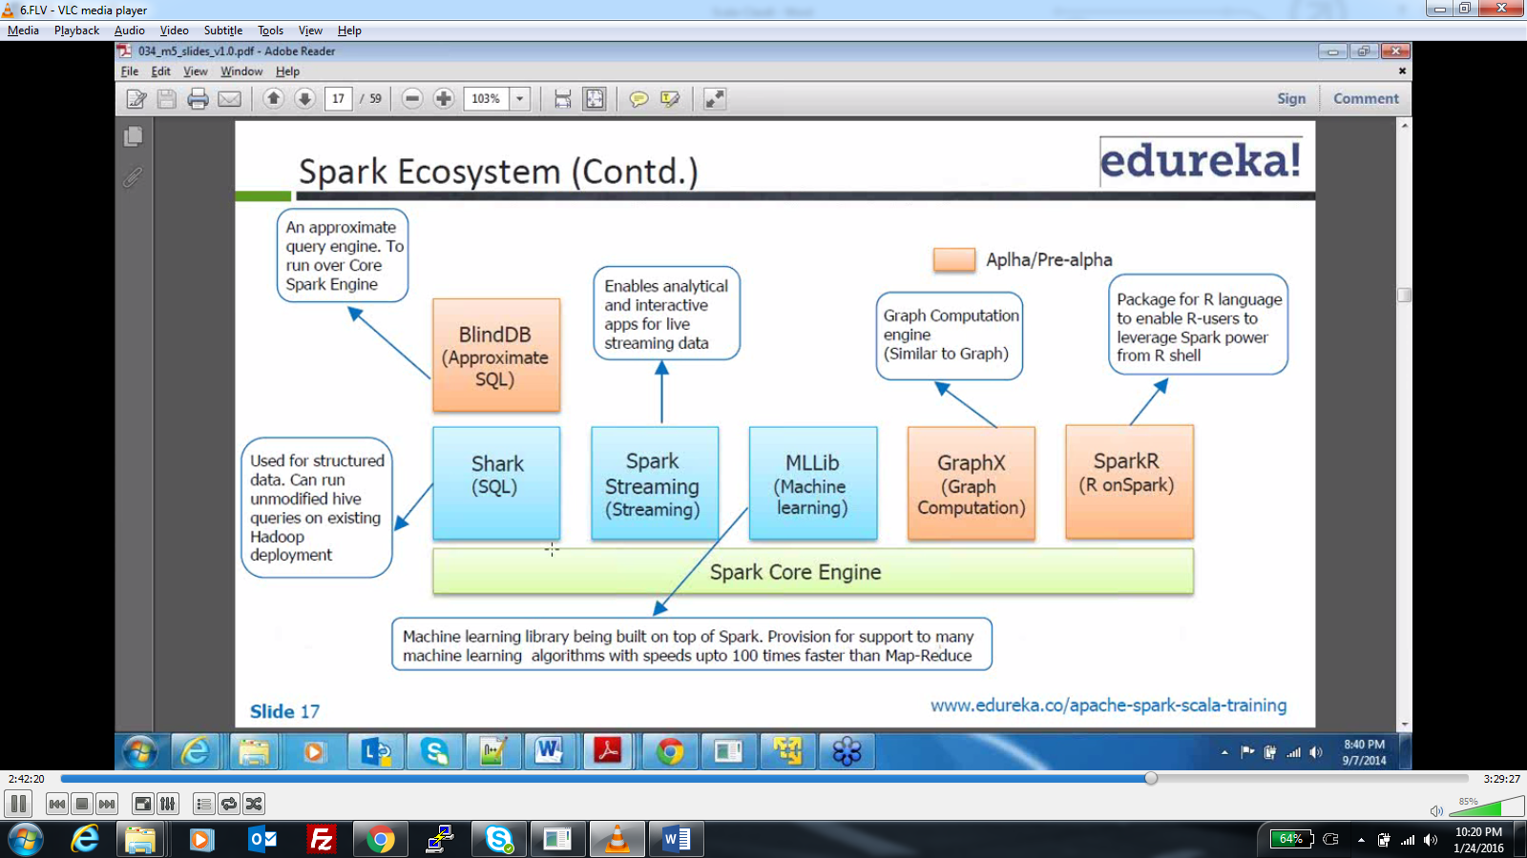

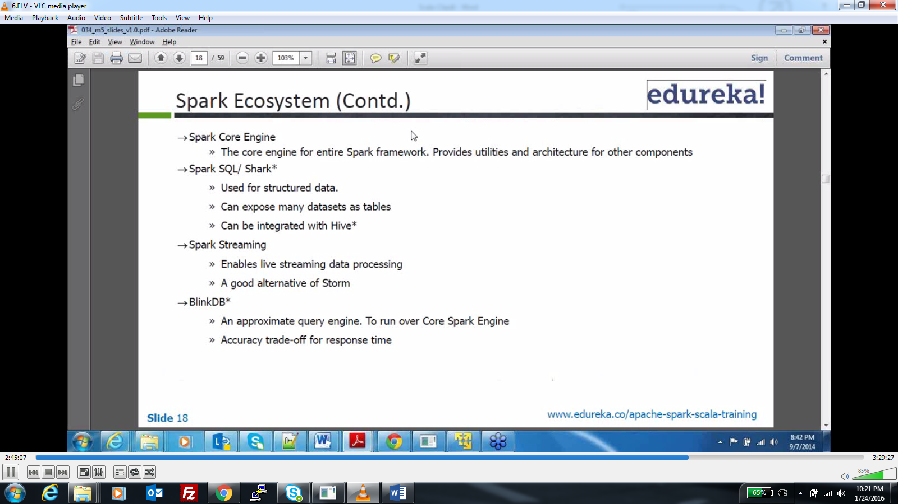

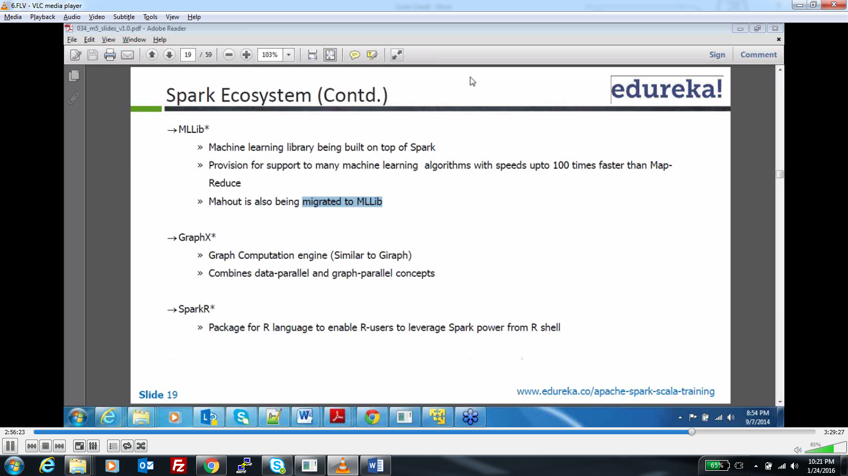

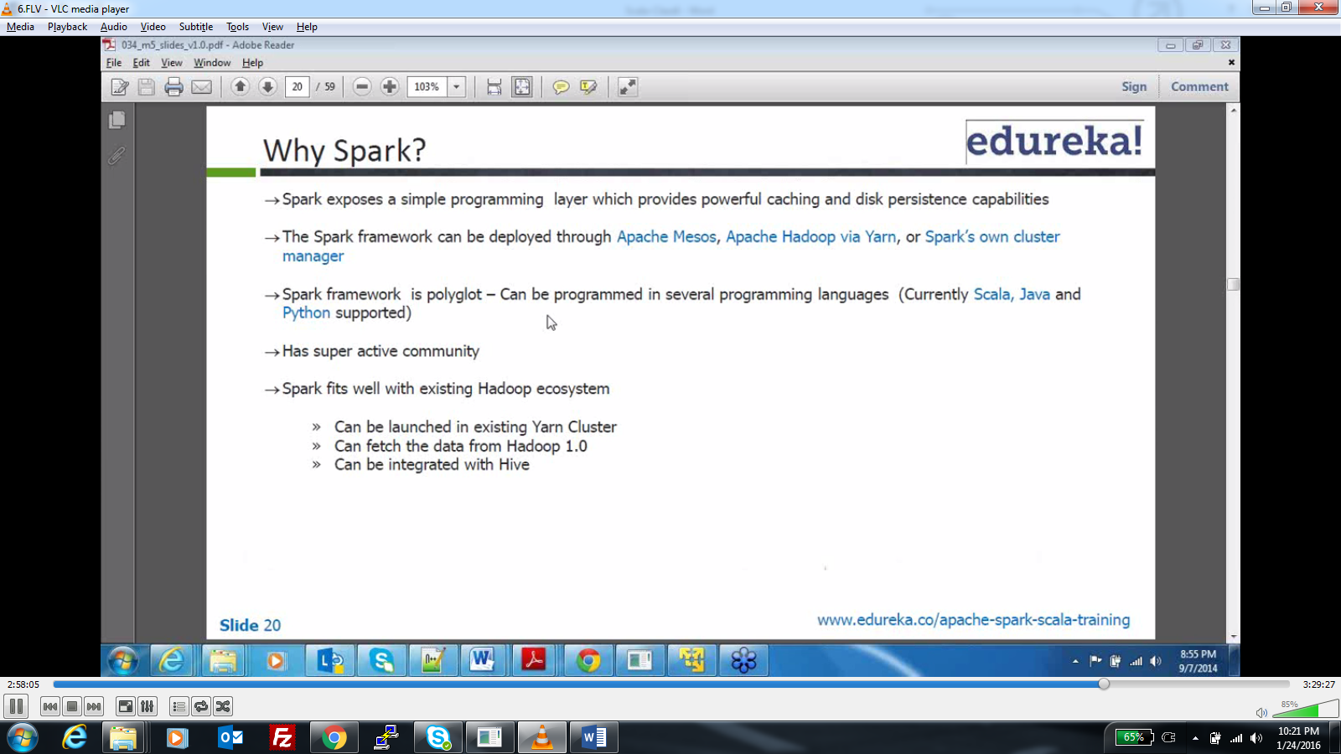

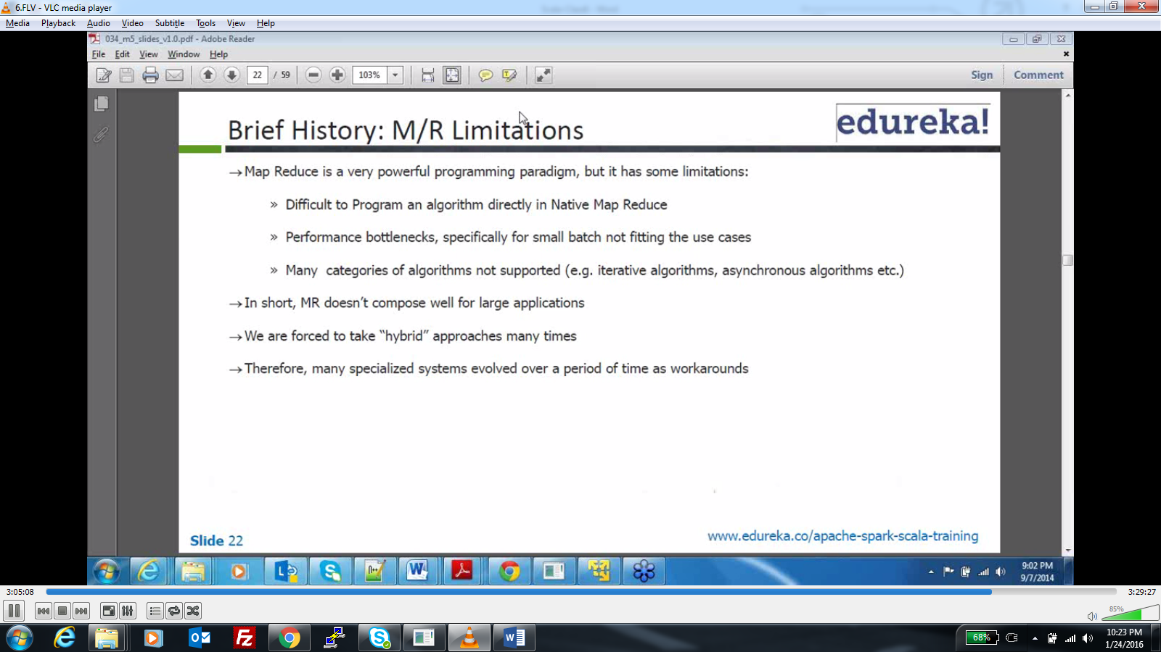

**Highlight iterative and asynchronous in classes**

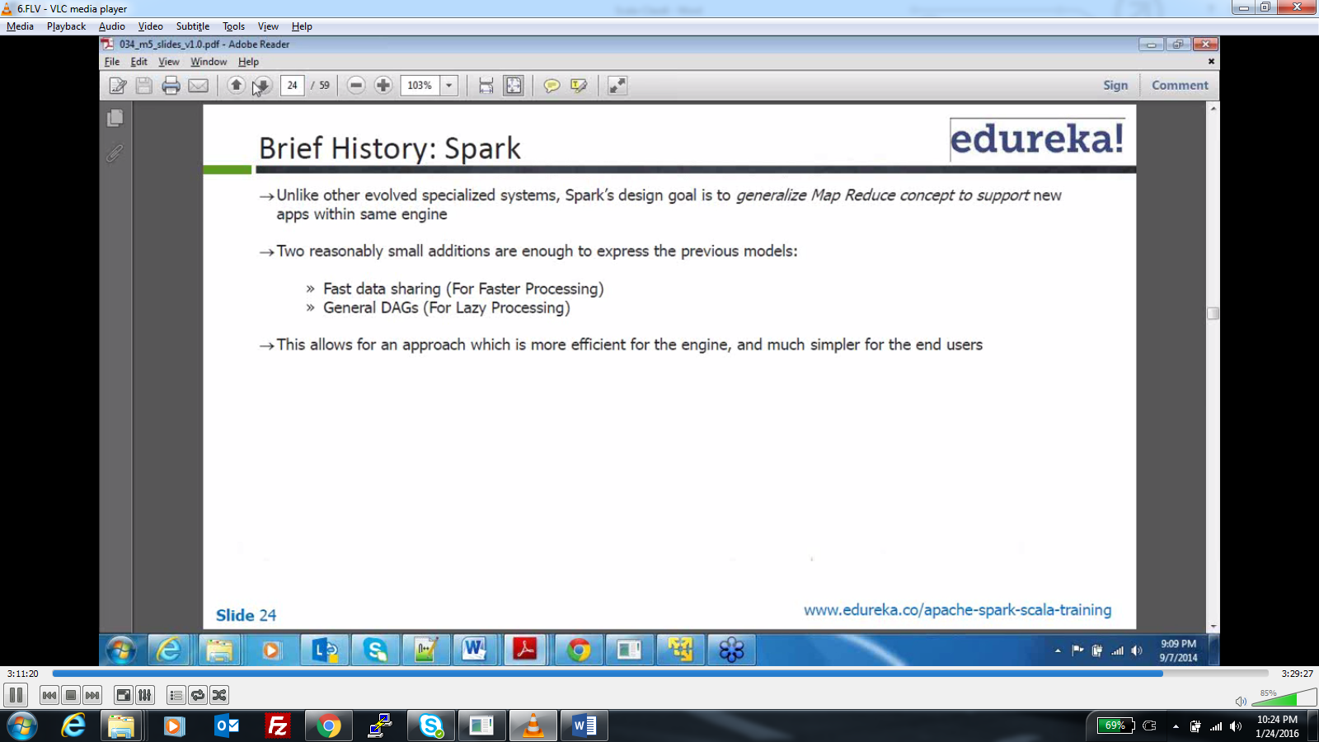

**Lazy processing because the RDD’s are initialized only when they are computed. Faster processing in terms of 1 sec**

**Storm is only for real time processing but spark has other components.**